# King Edward VI School



**GCSE Post-results Service**

**Summer 2025**

**Mrs Blyth  
Exams Officer**telephone: 01284 761393 (ext 206)   
email:[clb@king-ed.suffolk.sch.uk](mailto:clb@king-ed.suffolk.sch.uk)

Enclosed are your long-awaited exam results. Staff will be on hand when you collect your results and if your results were not what you expected, or you would like some guidance, please speak to your teacher or the Exams Officer.

**Grade boundaries**

Grade boundaries show the minimum number of marks you need for each grade. Exam board grade boundaries will be published on the Examinations area of the school website on results day from 9am. You can check this information to see how near a grade boundary a particular result that you have received is.

**Contact information**

All initial requests for these services must come directly from the student and therefore the school student email address must be used, but when completing the online form, an alternative email address should then also be given so that contact with them can continue once their school email address is no longer available

There are a number of post-results services available to you, and these are detailed below:

**Access to scripts (ATS service)**

A script refers to the written work of a candidate from an externally assessed component. The Access to Scripts service does not apply to internally assessed components, orals or audio/video tapes. It is recommended that students who are considering a clerical check or review of marking request the access to scripts service first. The deadline for this is **Tuesday** **2 September 2025**. Scripts will be received by the school within a week of the request. All requests for access to scripts must be done via the online application form on the exams page of the school website. Please note that requests for scripts should only be made where there is a genuine concern over the grade received, as it delays the exams office being able to deal with these as quickly otherwise.

**Review of Results**

If you wish to request a post-results service you must complete an online application form and submit this to the Exams Officer, together with the required fee by the published deadline. Applications received after the deadline will **not be accepted**. The application form can be found in the Examinations area of the school website.

**Service 1 - Clerical re-check**

Awarding bodies aim to provide an outcome to a clerical check request within 10 calendar days. This service includes the following checks:

* That all parts of the script have been marked
* The marks were all counted
* The result matches the marks on the paper

**Service 2 - Review of marking**

Awarding bodies aim to provide an outcome to a review of marking request within 20 calendar days.

This is a post-results review of the original marking to ensure that the agreed mark scheme has been applied correctly. **It is not a re-marking of the candidate’s script.**

The awarding body will have trained its reviewers to conduct reviews of marking accurately and consistently. **Reviewers will not re-mark the script.**

If you request a review of marking there are three possible outcomes:

* Your original mark will be confirmed as correct and there will be no change to your grade
* Your original mark may be raised and this may or may not result in a change of grade
* Your original mark may be lowered and this may or may not result in a change of grade

You can make an enquiry about the result (services 1 or 2) as long as you do so by **Tuesday 22 September 2025**.

**Service 3 - Review of Moderation**

This service is available for internally assessed coursework components that have been moderated. It is only available for whole subjects, not individual students.

A summary of the services available is below:

**ENQUIRIES ABOUT RESULTS & ACCESS TO SCRIPTS FEES**

|  |  |  |  |  |  |
| --- | --- | --- | --- | --- | --- |
| **Service** | **AQA (per paper)** | **OCR (per paper)** | **Pearson (per paper)** | **WJEC (per paper)** | **Deadline** |
| **Service 1 - clerical check**  Clerical check of all procedures leading to the issue of a result | £9.40 | £11.50 | £14.00 | £11.00 | 22/09/25 |
| **Service 2 - review of marking**  As for clerical check and to ensure the agreed mark scheme has been applied correctly | £43.50 | £65.25 | £50.00  (£65.00 to include a copy of the reviewed script) | £43.00  (no script available, review sent back with candidate report | 22/09/25 |
| **Service 3 - Moderation review**  Only available for whole subjects, not individual students, should be discussed directly with the Exams Officer (Costs from £250.00) |  |  |  |  | 22/09/25 |
| **ATS – Priority access to a copy**  A copy of the marked script to help you decide whether to request an enquiry about results | Free | Free | Free | Free | 02/09/25 |

If you wish to request a post-results service you must complete an online application form (in the Examinations area of the school website) and submit this to the Exams Officer. Your payment must be forwarded to Student Services. You can pay by ParentPay up until the 31 August 2025, at which stage the students will be taken off roll and this service will no longer be available, and payment will need to be made by cash or cheque (cheques should be made payable to ‘King Edward VI School’). Post result requests will not be processed until payment has been received.

**Teacher requests for access to scripts**

Teachers may wish to use exam scripts for teaching and learning purposes but they will first contact students to request their permission to do this, before requesting them from the Exams Officer who will make an application from the relevant Exam boards.

**Appeals**

If you make a request for service 1 or service 2 and are still not happy with the outcome you can request an appeal from the Exam board via the Exams Officer who can discuss the process for this and the costs.

**Exams Office**

The Exams Office is open to students each day during term time. It will also be open after the publication of exam results as follows:

Thursday 21 August 2025 9am-3pm Friday 22 August 2025 10am-1pm

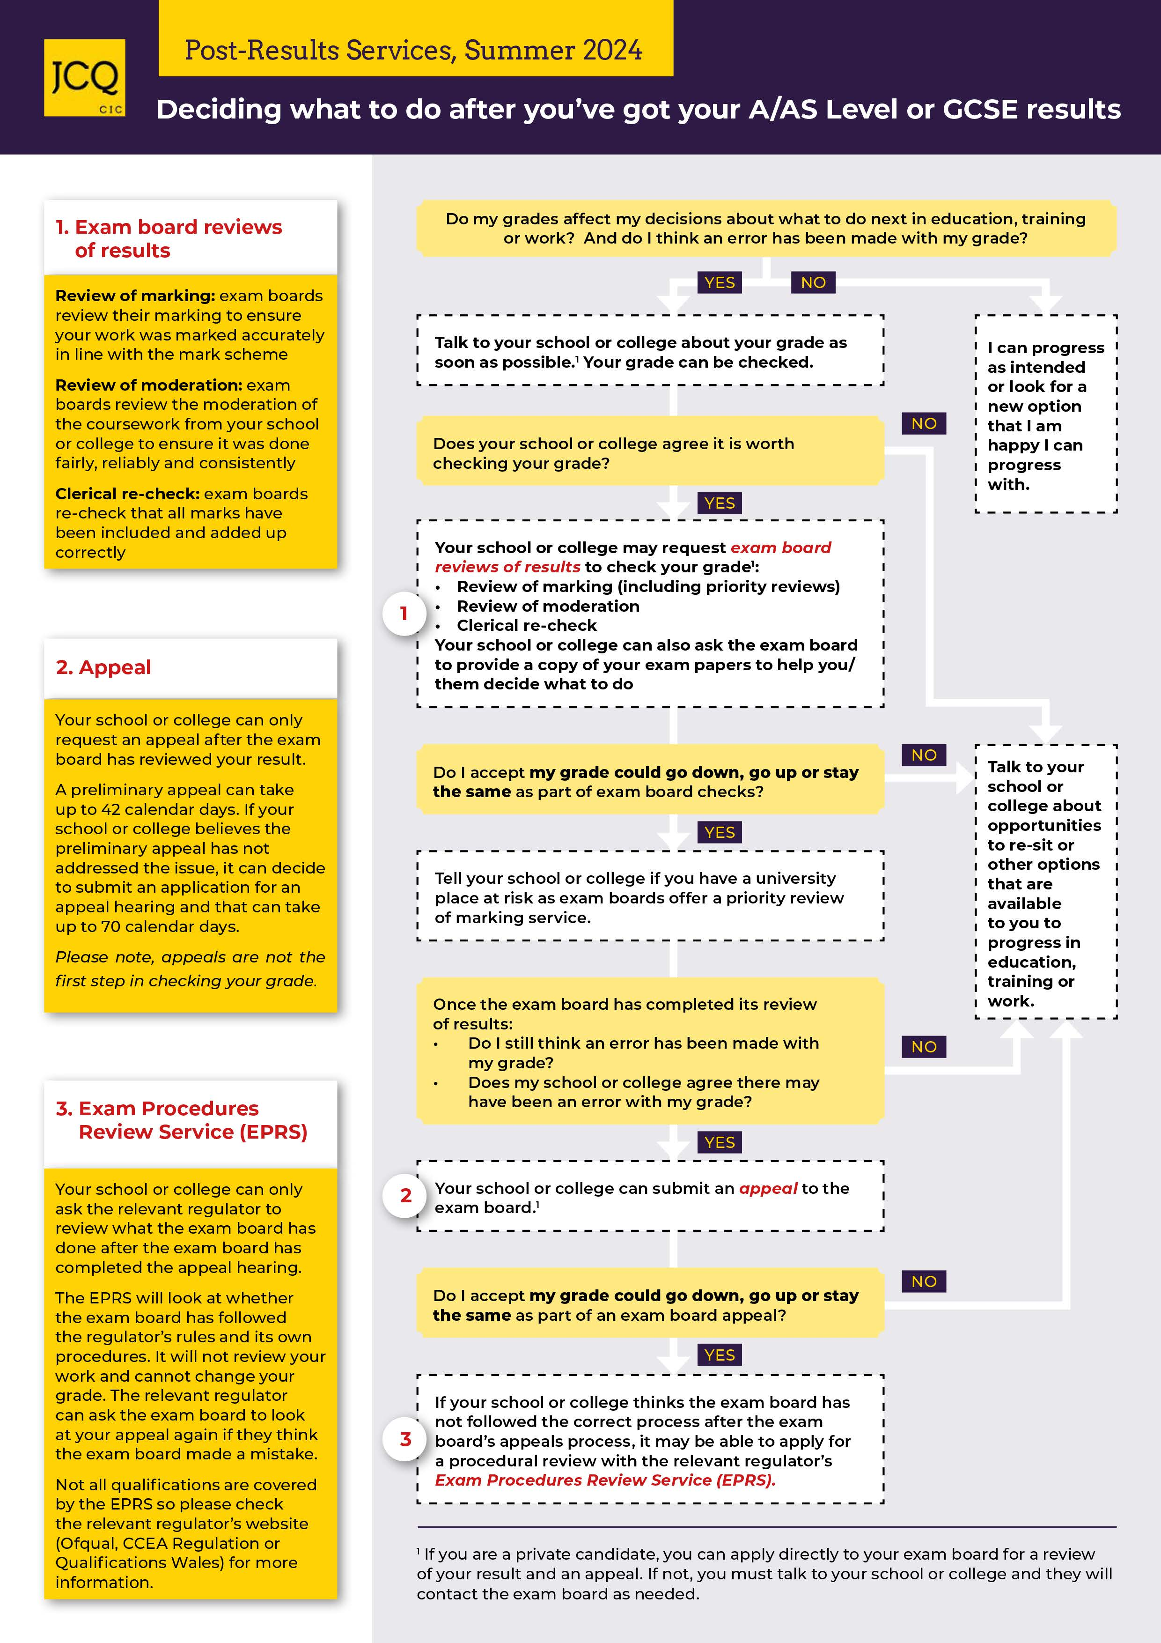Mrs Blyth, the Exams Officer, can be contacted by emailing [clb@king-ed.suffolk.sch.uk](mailto:clb@king-ed.suffolk.sch.uk)